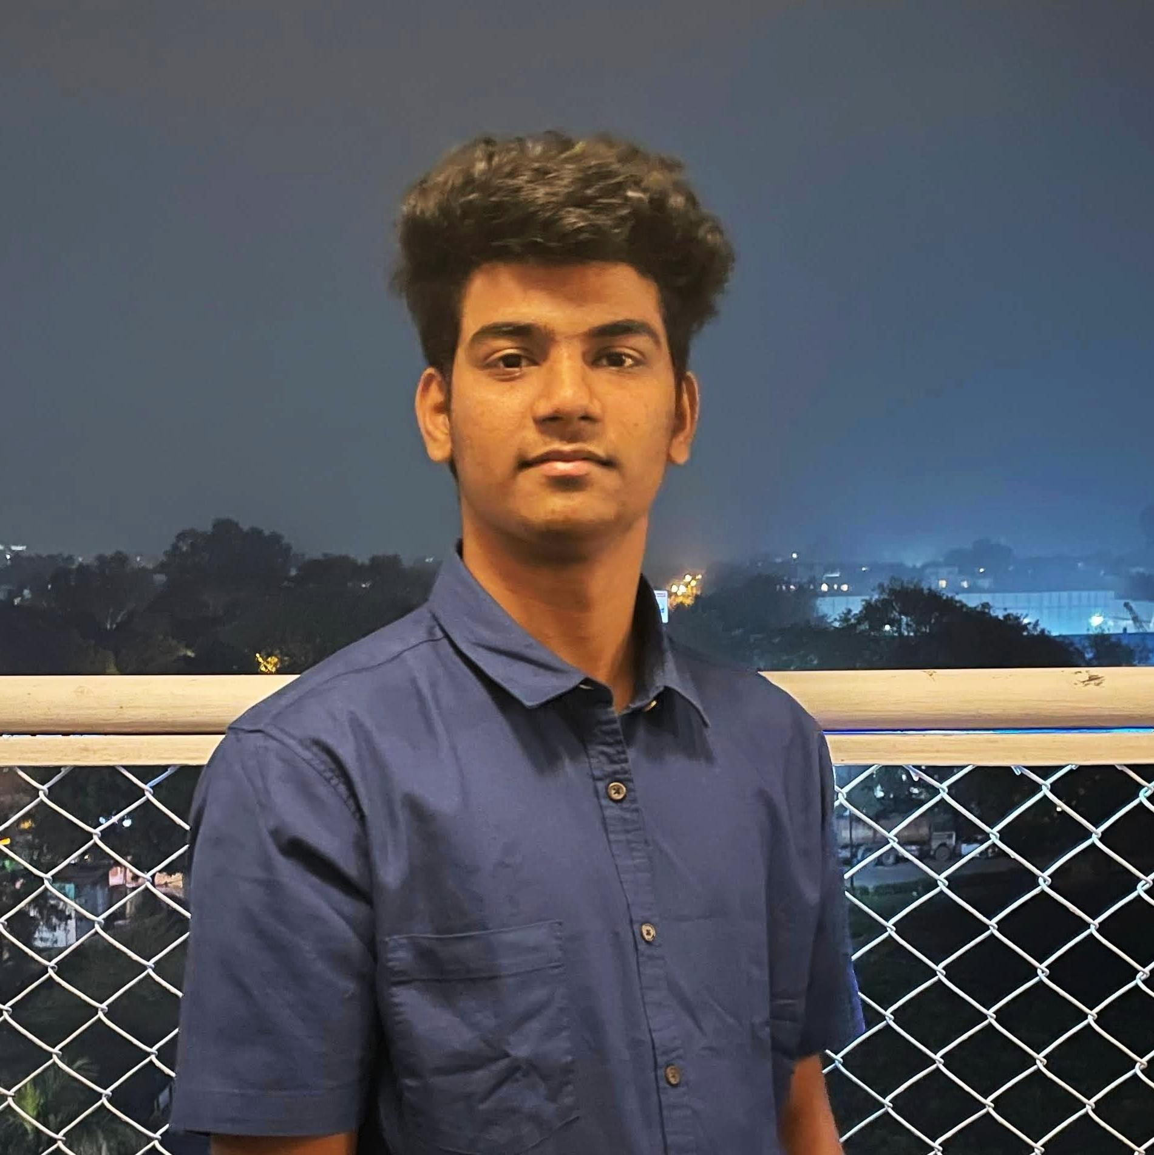

| **Vishnu Vardhan**  2020480, Email: [vishnu20480@iiitd.ac.in](mailto:vishnu20480@iiitd.ac.in) |
| --- |
| DOB: Feb 24, 2003 |
| Address: Hyderabad, Telangana, India  [LinkedIn](https://www.linkedin.com/in/vish24vishnu/) | [GitHub](https://github.com/V15hnu24) | [Website](https://my-project-2168c.web.app/) |
|  |

| **Education** |
| --- |

| **Indraprastha Institute of Information technology, Delhi**  B.Tech (CSE + Social Sciences) | CGPA: 7.45  (IVthSemester) |
| --- | --- |
| **Narayana Junior College, Hyderabad India**  Telangana State Board of Intermediate Education | Percentage: 92  2018 – 2020 |
| **Gowtham Model School, Hyderabad India**  Telangana State Board of Secondary Education | CGPA: 9.3  2020 |

| **Skills** |
| --- |

| **Expertise Area** | Problem Solving, Data Structure and Algorithms, Software Development |
| --- | --- |
| **Programming**  **Language** | Java, Python, SQL, JavaScript, Node JS, R, HTML, CSS, C, Bash, Flask |
| **Tools and**  **Technologies** | JavaFX, Express JS, Python Pandas, MySQL, MongoDB, Git, Bootstrap, [GitHub](https://github.com/V15hnu24) |
| **Technical Electives** | Data Structure and Algorithm, Database Management Systems, Critical Thinking and Reasoning in Social Sciences, Advance Algorithm and Analysis, Computer Organization, Probability and Statistics, Operating System, Discrete Mathematics, Linear Algebra, Econometrics, Convex Optimization. |

| **Experience** |
| --- |

| **Partner and Strategy at Memboro**  Aug 21 - Jul 22  [Memboro](https://memboro.com/), Delhi India   * Led the outreach team, worked on strategizing efficient ways to reach out and onboard Content Creators and social media influencers and also worked on business strategy and operations. |
| --- |
| * Built good public relations for the company, found new ways to contact influencers, and convinced them to join the platform. |
| **Co-Founder of Passious** Mar 22 - April 22  [Passious](https://passious-two.vercel.app/), Delhi India |

* Built good foundations for the startup and reviewed the development of the **Mobile application and Website.** Helped in Strategizing the outreach and Marketing.

| **Projects** |
| --- |

**Portfolio Website |** [**Link**](https://my-project-2168c.web.app/) **|** [**Github**](https://github.com/V15hnu24/Vishnu-portfolio-website)  May 22

* Developed Portfolio website using **HTML, CSS, JavaScript, Bootstrap** for frontend and **ExpressJs, NodeJS, and MongoDB** for Backend.

| **Found the relation between agriculture and health of the people |** [**GitHub**](https://github.com/V15hnu24/Regression) | April 22 – May 22  Team size - 5 |
| --- | --- |
| * Found the relation between health indicators such as the percentage of children demised from fever and data like agricultural conditions, and tap water facilities for all districts of India. * Cleaned and filtered huge data using **R, Python Pandas**, and **MS-EXCEL** techniques. Found the relation using Regression models, and visualized and analyzed the data relations using histograms.   **Backend for E-commerce website |** [**Github**](https://github.com/V15hnu24/Ecommerce-website)Mar 22 - April 22  Team size - 4   * Developed a fully functional backend and database for an Ecommerce website using **RDBMS**, **MYSQL**, **Flask**, **HTML**, **CSS**, and **JavaScript**. | |
| **Will Hero |** [**GitHub**](https://github.com/V15hnu24/Will-Hero-AP-)plementation of the existing cross-platform game Will   * An Implementation of the existing cross-platform game Will Hero using **Java**, **OOPS**, **JavaFX**, **CSS.** | Dec 2021  Team Size – 2 |
| **Positions of Responsibility** | |

| * Board Member Entrepreneurship Cell IIIT Delhi * Part of Salt N Pepper club IIIT Delhi * Ninja Entrepreneur Coding Ninjas | Jul 21 – Present  Jan 22 - April 22  Dec 21 – Mar 22 |
| --- | --- |

| **Awards and Achievements** |
| --- |

* Earned 3x of investment through affiliate marketing for a stock trading platform in 45 days (May 21 – Jun 21)

| **Interests and Hobbies** |
| --- |

| * Badminton * Reading about new technologies. |
| --- |
| * Reading and watching business and political news |

Declaration: The above information is correct to the best of my knowledge.

Vishnu Vardhan

Date: June 21, 2022